Name: Yasmien L. Tosloc Date:04/16/2026
Year & Section: BSIT- 3A Score:

Project Title
Co-Fit: Gym Operations and Membership System

Problem Statement
Traditional fitness gyms often rely on manual processes for membership registration, class scheduling, payment tracking, and member progress monitoring, leading to inefficiencies such as double-bookings, lost data, administrative errors, and poor member experience. Co-Fit: Gym Operations and Member Management System addresses these issues by providing a centralized, automated platform that enhances operational efficiency, improves member engagement, and reduces overhead costs for gym owners and staff.

Project Objectives
- To develop user-friendly software that manages the customer-staff relationship effectively.
- In order to save the customer records, staff members with the authority to access, change, and remove any record, as well as the service that the gym offers its customers.
- This allows for real-time scheduling and booking of fitness classes, personal training sessions, and equipment use, which reduces conflicts and enhances resource utilization.
- To monitor members’ progress through workout logs, attendance records, and health metrics, facilitating tailored fitness plans and boosting member retention.
- To guarantee secure data management and mobile accessibility, enabling members to access the system at any time and from any location, thereby improving overall user satisfaction.

Target Users
Gym Members: People who subscribe to the gym for fitness activities like workouts, classes, and personal training sessions. The system will be used for booking sessions, tracking progress, managing payments, and viewing schedules.

Gym Staff: Trainers, front-desk staff, and those handling daily activities. The system will be used for scheduling, managing members, and creating reports.

Administrators/Owners: Individuals managing the gym who are responsible for all aspects of operation, such as financials and analytics.
System Scope
Included:
- User registration and profile management (for members and staff).
- Class and session scheduling with real-time availability.
- Payment processing and membership renewals.
- Progress tracking (e.g., workout logs, attendance records).
- Mobile-responsive interface for web and app access.
- Secure login and data encryption.

Excluded:
- Integration with third-party fitness wearables (e.g., Fitbit or Apple Watch) beyond basic data import.
- Advanced AI-driven personalized recommendations (limited to manual trainer inputs).
- Physical hardware management (e.g., controlling gym equipment directly).
- Multi-location support (focused on a single gym site initially).
- Offline functionality (requires internet connectivity).

UML Diagram
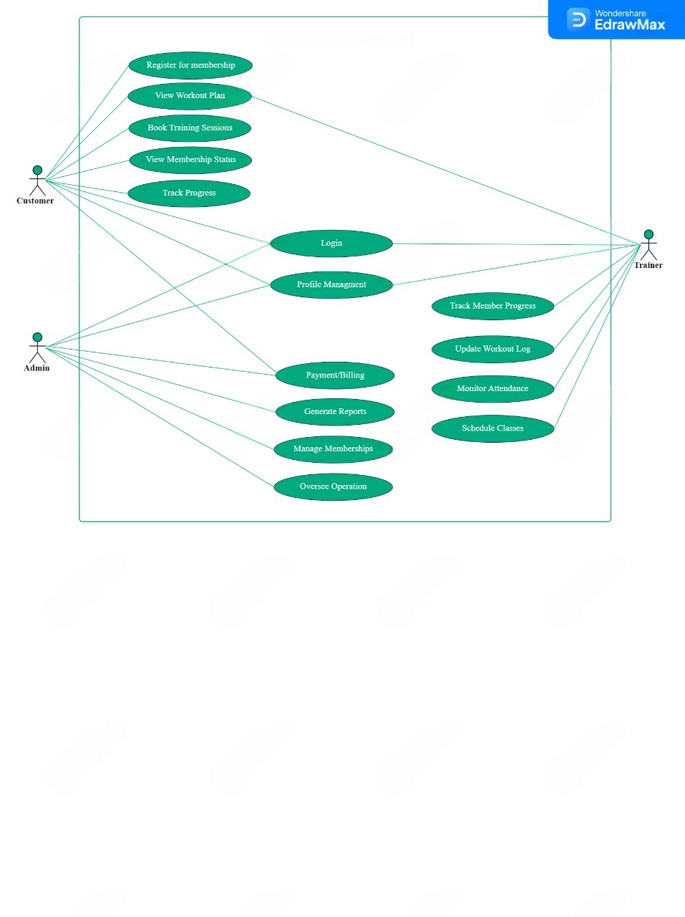
Co-Fit: Gym Operations and Member Management System

